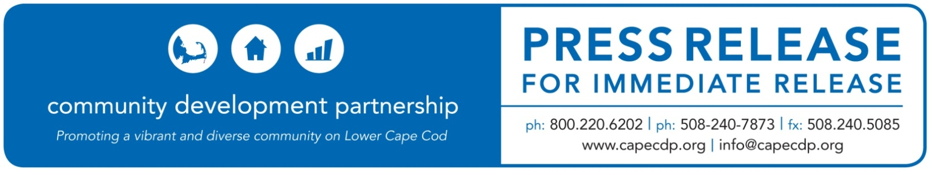
Eastham

Name of Event: Community Development Partnership – Welcomes New Board Members and Officers

Today’s Date: May 20, 2022

For Additional Information Contact:
Nina Cantor, Chief Development & Communications Officer
Community Development Partnership
3 Main Street Mercantile, Unit 7, Eastham MA 02642
508-290-0125, nina@capecdp.org

Community Development Partnership
Welcomes New Board Members and Elects New Slate of Officers

Eastham, MA – At the Community Development Partnership’s Annual Meeting on May 19, 2022, over 50 members unanimously elected a slate of Board Officers and three new Board members to the CDP’s Board of Directors. This year’s meeting was held virtually.

New members David Koven, Robert MacCready, and Mary Nee were elected to the Board for a for a 3-year term.

David Koven has worked as a developer, housing program administrator, planner, and community organizer over the past 40 years and has provided productive consulting services to clients seeking to develop or invest in affordable housing projects since 1994. He has completed projects ranging from six to 300 units, for a total of about 3,000 units, both preservation and new construction. Throughout his career, he has crossed paths with over 50 nonprofits, the majority of whom are community development corporations.

Robert MacCready (Bob) retired from the Hyannis-based Housing Assistance Corporation at the end of 2017 after a decade of serving as their Chief Financial Officer (CFO). Prior to this, he had been CFO of Dorchester Bay Economic Development Corporation in Boston for six years. Bob, a certified CPA, has a BS degree from MIT and MS degree in accounting from Northeastern University’s D’Amore-McKim School of Business and Bentley College. He has served on various committees in Harwich and is on the Board of Cape Cod Village in Orleans.

Mary Nee retired in 2020 from her position as CEO of the Animal Rescue League after a 40+ year career leading Boston-based governmental and non-profit organizations. Her career has spanned several fields including community development and housing; capital planning; public construction, finance, and education; homeless services; addiction treatment; public advocacy, and animal welfare. She has served on numerous public, private and nonprofit Boards including MassHousing, and the Boston Water and Sewer Commission. Currently, she serves as Chair of the Town of Eastham’s Residential Zoning Task Force.

Members elected a new slate of Officers for the coming fiscal year. Steve Cole of Eastham was elected as Chair, Carole Ridley of Harwich, was elected as vice-chair, Mary Nee of Eastham as Treasurer, with Jennifer Cusack remaining as Clerk.
Steve Cole has been Treasurer of CDP since 2020. Before retiring in 2009, he was the CEO of the national Better Business Bureau organization and held senior positions in State and Federal agencies. On the Cape, Steve has been active in the community, serving as Town Moderator in Eastham, Vice Chair of the Town’s Finance Committee, a founding Board member of Nauset Neighbors (a nonprofit helping to allow seniors to age in place), Treasurer of Cape Rep Theater, and President of Nauset Newcomers, an organization that helps new Cape residents make connections in the community. “It is a privilege to have the opportunity to serve the Lower and Outer Cape in this way. The CDP is one of the most important organizations in the region, advocating for small business development and growth, and for affordable and community housing,” said Steve. “If CDP didn’t exist, we’d have to invent it – the need is greater than ever,” he added.
“We are excited to welcome our three new Board members who each bring their own set of experiences and skills that will help us move forward as we enter our 30th year,” continued Steve. “Serving as a Board member is a strategic way to serve the Lower Cape community and contribute to the economic diversity and sustainability of our region.”

Matt Cole, President and CEO of Cape Associates, has served as Chair since 2020, and will continue to serve on the Board as Immediate Past President.

The Community Development Partnership (CDP) is governed by an eighteen-member Board of Directors who all live or work within the agency’s service area. To learn more about the CDP Board members, visit capecdp.org.

ABOUT THE COMMUNITY DEVELOPMENT PARTNERSHIP

The Community Development Partnership leads the Lower Cape in building a diverse year-round community of people who can afford to live, work, and thrive here. To accomplish our mission, we promote, develop, and manage affordable housing; nurture the launch and growth of small businesses; and facilitate collaboration with business, nonprofit, and government partners.

To find out more information about Community Development Partnership, visit www.capecdp.org.

This institution is an equal opportunity employer and provider.

###

