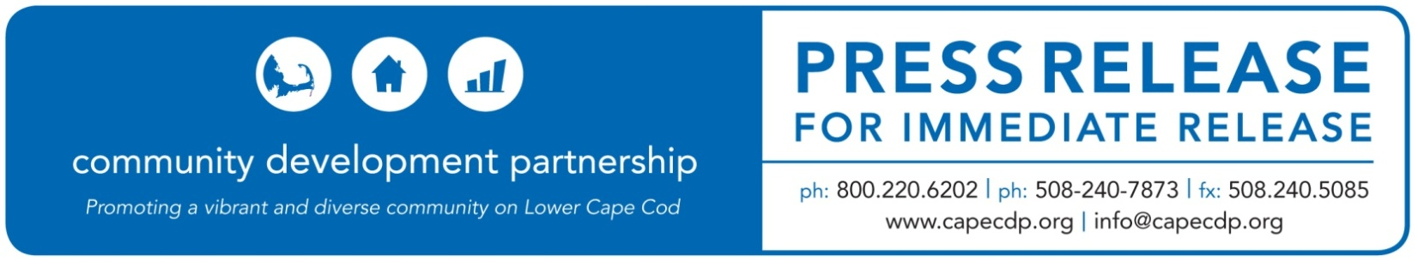

**Eastham**

**What:** Community Development Partnership to offer Community Development Block Grant funded forgivable loans to Lower Cape Businesses

**Date:** September 10, 2020

**For Additional Information Contact:**

Ann C. Robinson, Chief Program Officer

Community Development Partnership

3 Main Street Mercantile, Unit 7, Eastham MA 02642

508-240-7873 ex 13, [ann@capecdp.org](mailto:ann@capecdp.org)

**Community Development Partnership to offer $400,000 in Community Development Block Grant funded forgivable loans to Lower Cape Businesses**

The Community Development Partnership (CDP) is pleased to bring critical financial relief to Lower Cape small businesses through forgivable loans of up to $10,000 to businesses with five or fewer employees, also known as micro-enterprises. Funds of $400,000 were awarded to the Town of Truro through HUD’s Community Development Block Grant program (CDBG) to assist small businesses affected by COVID-19 impacts.

The grant program, administered by the CDP, supports low-to-moderate income business owners and is part of the CDP’s ongoing efforts to support small business, particularly to those who have been disproportionately impacted by the global pandemic and the resulting economic crisis.

To support this program and help revitalize the local economy, the CDP has been awarded $20,000 from the Cape Cod Foundation to continue its small business recovery efforts through workshops, technical assistance and access to capital.

“The work of the Community Development Partnership in supporting our local small businesses as they recover from the impact of the COVID-19 pandemic is essential”, stated Kristin O’Malley, President and CEO of The Cape Cod Foundation. “We are honored that we can support their efforts to help revitalize our local economy.”

CDP CEO, Jay Coburn noted that “The Cape Cod Foundation’s support is very much appreciated and is helping us to leverage $400,000 in relief for our region’s most vulnerable small businesses.”

Since the pandemic began in mid-March, the CDP has been “open for business” providing ongoing support to the business community. Initially, the CDP helped businesses navigate the Federal Paycheck Protection Program (PPP) and Economic Injury Disaster Loan (EIDL) programs through one on one technical support and to date has served over 125 businesses.  The CDP’s monthly e-blast, *Inside Scoop*, has become a weekly guide to COVID-19 assistance and resources.

Business owners who are interested in learning more about the forgivable loan program should contact Pam Andersen at [pam@capecdp.org](mailto:pam@capecdp.org) or call 508-240-7873 x18.

**ABOUT THE COMMUNITY DEVELOPMENT PARTNERSHIP**

The Community Development Partnership leads the Lower Cape in building a diverse year-round community of people who can afford to live, work and thrive here.  To accomplish our mission, we promote, develop and manage affordable housing; nurture the launch and growth of small businesses; and facilitate collaboration with business, non-profit and government partners.

To find out more information about this organization, go to [www.capecdp.org](http://www.capecdp.org).

*The Cape Cod Foundation is a community foundation whose mission is to build permanent charitable resources for community betterment through informed grantmaking and civic leadership. The Foundation has distributed more than $70 million in grants and scholarships since its founding in 1989.* [*www.capecodfoundation.org*](http://www.capecodfoundation.org)

This institution is an equal opportunity employer and provider.

*###*