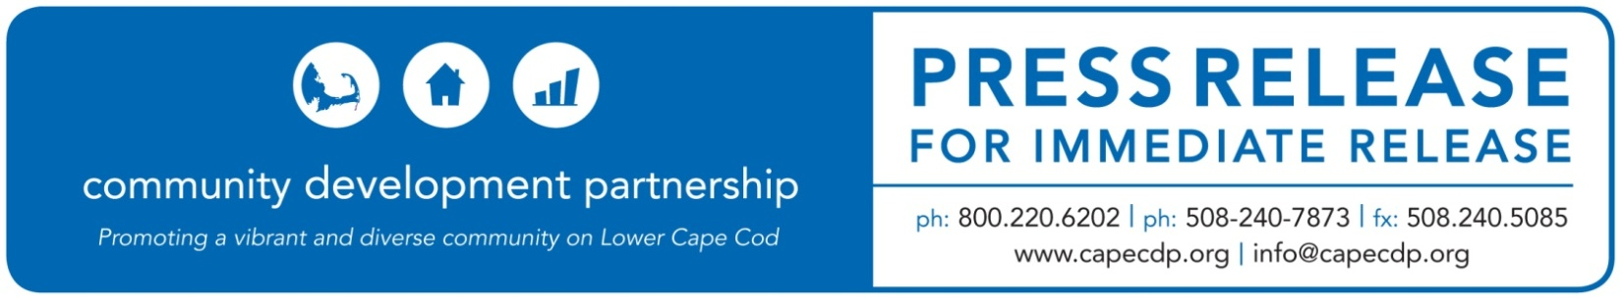
Eastham

Name of Event: Community Development Partnership Announces Recipients of Community Awards at 29th Annual Meeting

Today’s Date: April 2, 2021

For Additional Information Contact:
Jay Coburn, Chief Executive Officer
Community Development Partnership
3 Main Street Mercantile, Unit 7, Eastham MA 02642
508-240-7873 ex 16, jay@capecdp.org

Community Development Partnership
To Hold 29th Annual Meeting and Present Community Awards

Eastham, MA – The Community Development Partnership (CDP) announces the celebration of their 29th Annual Meeting on Thursday, April 22nd and invites Lower Cape residents to attend. The Meeting will be held virtually via Zoom, and is a time to acknowledge the organization’s achievements and important community partners, as well as to share plans for the future.

They will also honor members of the community with two annual awards, the Gwen Pelletier Award for Excellence in Community Service and Norm Edinberg Award for Excellence in Entrepreneurship. In addition, new Board members and officers will be elected.

“The 2021 Annual Meeting marks the beginning of a celebration of the CDP’s 30th year of creating opportunities for people to live, work and thrive on the Lower Cape,” said CDP Chief Executive Officer, Jay Coburn. “We are eager to honor our awardees, celebrate our past accomplishments and share our exciting plans for the future.”

The 16th Annual Gwen Pelletier Award for Excellence in Community Service will be presented this year to Vicki Goldsmith, the former Executive Director at Habitat for Humanity of Cape Cod. Habitat’s core mission is to serve and encourage economic diversity and stability across the Cape by “partnering with families in need of an affordable home to build one of their own; fostering stability, self-reliance and a strong sense of community.”

Guided by a belief in the power of collaboration as well as strongly held moral and spiritual convictions, Vicki led staff, volunteers, homeowners, municipal partners and whole communities in the creation of 140 homes. These homes are then sold affordably to proud new homeowners, who enjoy long term housing stability, and with that, new found economic success.

An exemplary individual who embodies the spirit of the award, having contributed to the diversity, economy, and care of Cape Cod, Vicki led Habitat for 20-years, ending with her retirement in December 2019.

The CDP’s 7th Annual Norm Edinberg Award for Excellence in Entrepreneurship will be presented to J’aime and Christian Sparrow, Karen Densmore, and Garret Smythe, the owners of Sunbird Kitchen in Orleans.

Sunbird Kitchen began in 2010 as a food truck in Wellfleet. Through a micro-loan from the CDP, the Sparrows were able to access capital to help with start-up food costs and equipment. After a successful couple of years, they opened Sunbird Kitchen, their brick and mortar location in Orleans in 2015. Their goal was to create a business that engaged customers in an experience. Sunbird Kitchen would provide fresh, quality, local food served by friendly staff in a visually appealing surrounding that would offer a warm, engaging community atmosphere. J’aime’s background in the food and hospitality industries and Christian’s visual design and branding expertise were critical to its success. Business partner Karen Densmore joined Jamie and Christian in creating a place for their ‘flock’ to gather throughout the year.

The Coronavirus pandemic has provided significant challenges to most restaurants on the Lower Cape and Sunbird Kitchen was no exception. Jamie, Christian, Karen and now with chef/co-owner Garret Smythe have transformed the business into Sunbird Provisions, offering homemade takeout and specialty products. Sunbird Kitchen supports the Lower Cape Community through its collaboration with many local growers and foragers who take pride in their craft and serving their community, including Halcyon Farm, Chatham Bars Inn Farm, Lewis Brothers Ice Cream, and Midnight Our Scallops.

The CDP’s Annual Meeting and Community Awards is generously sponsored by Seamen’s Bank and Kerry Insurance Agency. This event is free, but registration is required. To register go to: www.capecdp.org/upcoming-events

ABOUT THE COMMUNITY DEVELOPMENT PARTNERSHIP

The Community Development Partnership leads the Lower Cape in building a diverse year-round community of people who can afford to live, work and thrive here. To accomplish our mission, we promote, develop and manage affordable housing; nurture the launch and growth of small businesses; and facilitate collaboration with business, non-profit and government partners.

To find out more information about this organization, go to www.capecdp.org.

This institution is an equal opportunity employer and provider.
###

