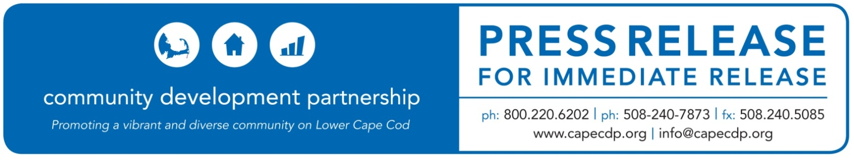
Eastham

What: Mary-Louise & Ruth N. Eddy Foundation Awards the CDP $20,000 to support resident services on the Lower Cape
Date: October 20, 2020

For Additional Information Contact:
Britt Beedenbender, Chief Development and Communications Officer
Community Development Partnership
3 Main Street Mercantile, Unit 7, Eastham MA 02642
508-240-7873 ex 25, Britt@capecdp.org

Eddy Foundation Awards the CDP $20,000 to support resident services on the Lower Cape

The Mary-Louise & Ruth N. Eddy Foundation has awarded the Community Development Partnership $20,000 to support their Resident Support Services on the Lower Cape.

Through a partnership with Homeless Prevention Council, the CDP connects residents of its affordable housing units with the appropriate resources to meet their needs—such as childcare, employment, education and health/mental health/nutrition benefits assistance. The need for this program has become even greater as families deal with the economic, social and mental health impacts of the COVID19 pandemic.

Funds from the grant will also be used to support residents at Canal House – the CDP’s sober living residence in Orleans. Canal House, which serves low-income individuals in recovery from alcohol and substance abuse, houses 5 men, 3 women, and an on-site manager. Canal House supports residents in recovery by providing a safe, affordable living environment free from the pressures that can fuel addiction, allowing individuals to focus on recovery and a successful transition back into a healthy community. Since 1998, Canal house has served over 150 individuals.

The Eddy foundation has been a regular supporter of the CDP’s housing initiatives, awarding nearly $300,000 since 2008.

ABOUT THE COMMUNITY DEVELOPMENT PARTNERSHIP

The Community Development Partnership leads the Lower Cape in building a diverse year-round community of people who can afford to live, work and thrive here. To accomplish our mission, we promote, develop and manage affordable housing; nurture the launch and growth of small businesses; and facilitate collaboration with business, non-profit and government partners.

To find out more information about this organization, go to www.capecdp.org.

This institution is an equal opportunity employer and provider.

###

