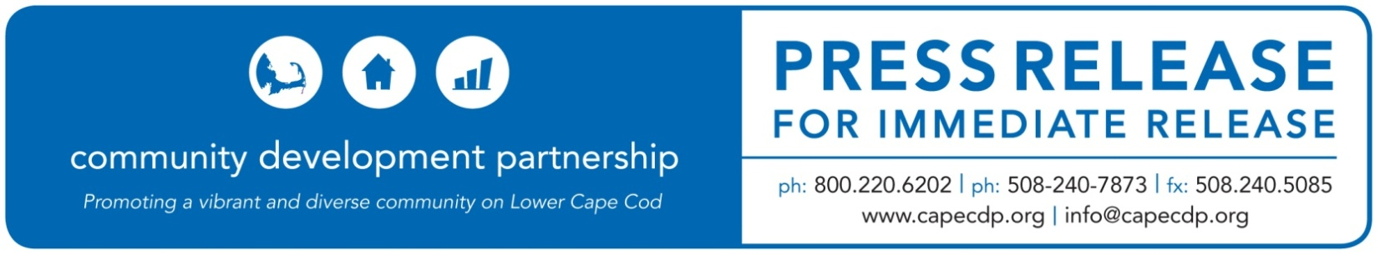

**Eastham**

**What:** Lower Cape Coalition of non-profit organizations commit to addressing racial injustice and stand with those protesting the countless victims of racial injustice.

**Release Date:** June 4, 2020

**For Additional Information Contact:**

Britt Beedenbender, Chief Development and Communications Officer

Community Development Partnership

3 Main Street Mercantile, Unit 7, Eastham MA 02642

508-240-7873 ex 25, [britt@capecdp.org](mailto:britt@capecdp.org)

**Lower Cape Coalition of non-profit organizations commit to addressing racial injustice and stand with those protesting the countless victims of racial injustice.**

Today an alliance of 7 Lower Cape non-profits issued a joint statement in response to the killing of George Floyd and countless victims of violence and racial injustice.

Cape Cod Children’s Place, Community Development Partnership, The Family Pantry of Cape Cod, Helping Our Women, Homeless Prevention Council, Lower Cape Outreach Council, and WE CAN expressed their solidarity with Black & Brown Americans and other marginalized communities to demand justice and accountability.

The statement reads as follows:

“We support those who condemn the murders of George Floyd and countless victims of violence and racial injustice. We stand in solidarity with Black & Brown Americans and other marginalized communities to demand justice and accountability.  
  
We see these events as manifestations of cultural, systemic and institutionalized racism upon which this country was founded and which clearly persists to this day. We share the anger, frustration and sadness that these events provoke and the determination to accept responsibility and do our part to undo the systemic racism that exists in our country.

We recognize that structural racism exists throughout all levels of our society. We see it in our public health systems and how the social determinants of health have inflicted disproportionate harm on communities of color as a result of COVID19. We see it in our economic system as people of color are disproportionately affected by the current economic crisis. We see it in our educational, food, housing, transportation and environmental systems.

To create change, we must first look inward and critically ask: What do we need to learn and unlearn, as individuals and as organizations? How can we be better employers and partners? Are our internal structures anti-racist and do they provide equitable opportunities?

As an alliance of health and human services organizations, we are committed to building and strengthening each of our organizations’ capacity for diversity, equity and inclusion. While we collectively serve thousands of Cape Cod residents and families, who represent great diversity, this is not mirrored in our organizations. Fostering justice, equity, diversity, and inclusion is an active process. We are still learning. We are dedicated to doing the work and invite other social service agencies to join us in our commitment.

Prior to recent events, our organizations agreed and committed to develop and engage in Diversity, Equity and Inclusion training for ourselves, our staff, our leadership, and our volunteers. This will be our first step. Amidst our collective grief and anger, we take strength from being in community with all of you and in solidarity with the broader movement for justice sweeping our Country.”

**ABOUT THE COMMUNITY DEVELOPMENT PARTNERSHIP**

The Community Development Partnership leads the Lower Cape in building a diverse year-round community of people who can afford to live, work and thrive here. To accomplish our mission, we promote, develop and manage affordable housing; nurture the launch and growth of small businesses; and facilitate collaboration with business, non-profit and government partners.

To find out more information about this organization, go to [www.capecdp.org](http://www.capecdp.org).

This institution is an equal opportunity employer and provider.

*###*