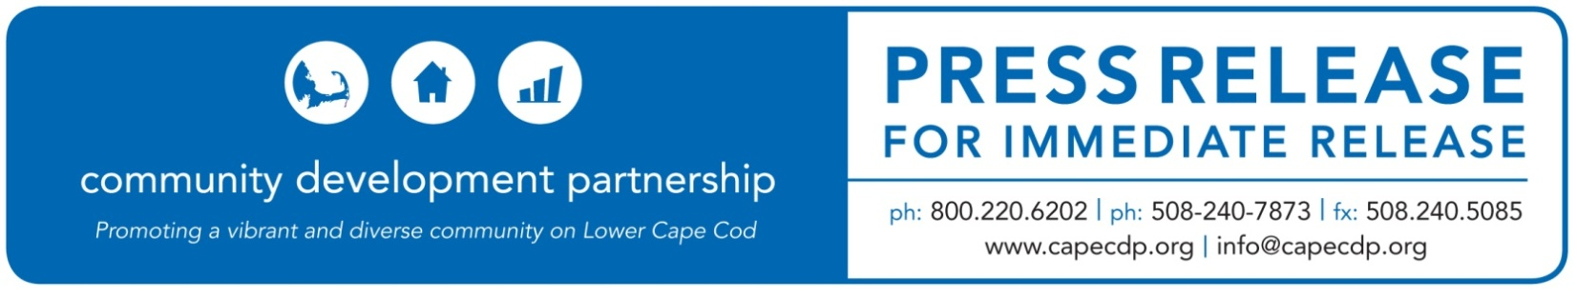
Eastham

What: Rockland Trust Charitable Foundation Awards the CDP $5,000 to Business & Credit Programs
Date: November 9, 2020

For Additional Information Contact:
Ann Robinson, Chief Program Officer
Community Development Partnership
3 Main Street Mercantile, Unit 7, Eastham MA 02642
508-240-7873 ex 13, Ann@capecdp.org

Rockland Trust Charitable Foundation Awards the CDP $5,000
to support Business & Credit Programs

The Rockland Trust Charitable Foundation has awarded the Community Development Partnership $5,000 to support Business and Credit Programs on the Lower Cape.

As the economic uncertainty generated by the COVID-19 pandemic stretches into fall and winter, the needs of the Lower Cape business community continue to evolve. Grant funds will be used to support comprehensive assistance to small businesses to provide them with the knowledge and tools they need to survive this current economic and health crisis.

“The pandemic has caused a disproportionate level of stress on the Lower Cape’s small business community,” says CDP CEO Jay Coburn. “We anticipate that more businesses will require individualized assistance to weather he disruption caused by the emergency measures to combat coronavirus. We are grateful to Rockland Trust for their support as it will allow the CDP to continue to adapt our own programs and strategies to respond to the evolving needs of the business community.”

Funding will be used to support an array of programs to cover the spectrum of needs for businesses in our community. This includes educational workshops to provide businesses with new skills and resources; individualized technical assistance to help businesses start, pivot, stabilize, or grow; micro-loans to startups and existing businesses that are unable to obtain funding through conventional sources; and professional services grants to help offset consulting costs.
“We are grateful to be able to support this organization and their invaluable service to our communities on Cape Cod,” said Edward Seksay, President and Chair of the Rockland Trust Charitable Foundation.

ABOUT THE COMMUNITY DEVELOPMENT PARTNERSHIP

The Community Development Partnership leads the Lower Cape in building a diverse year-round community of people who can afford to live, work and thrive here. To accomplish our mission, we promote, develop and manage affordable housing; nurture the launch and growth of small businesses; and facilitate collaboration with business, non-profit and government partners.

To find out more information about this organization, go to www.capecdp.org.

This institution is an equal opportunity employer and provider.

###

