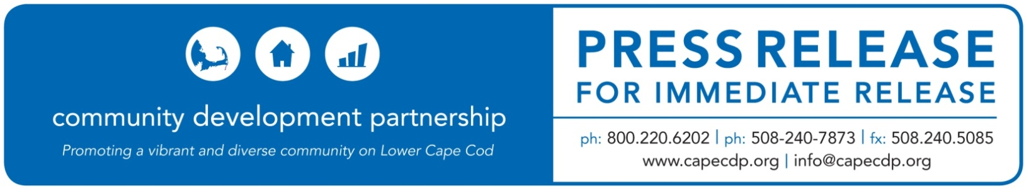
Eastham

What: Seamen’s Bank Long Point Charitable Foundation Awards the CDP $15,000 to Business & Credit Programs
Date: November 19, 2020

For Additional Information Contact:
Ann Robinson, Chief Program Officer
Community Development Partnership
3 Main Street Mercantile, Unit 7, Eastham MA 02642
508-240-7873 ex 13, Ann@capecdp.org

Seamen’s Bank Long Point Charitable Foundation Awards the CDP $15,000
to support Business & Credit Programs

Seamen’s Bank Long Point Charitable Foundation has awarded the Community Development Partnership $15,000 over three years to support Business and Credit Programs on the Lower and Outer Cape.

While many local businesses have shown resilience in their ability to adapt and innovate, many continue to suffer from the economic impacts of the COVID-19 pandemic. As the needs of the business community evolve, the CDP will evaluate and adapt their programming to meet those needs.

The funds from this grant will be used over the next three years to provide critical support to businesses as they adapt and recover from the challenges presented by Covid-19 as well as helping new enterprises get started and grow.

Among the programs supported are educational workshops to provide businesses with new skills and resources; individualized technical assistance to help businesses start, pivot, stabilize, or grow and professional services grants to help offset consulting costs. The grant from Seamen’s Bank Long Point Charitable Foundation will also support micro-loans to startups and existing businesses that are unable to obtain funding through conventional lenders; and administration of $400,000 in CDBG forgivable loans to micro-enterprises owned by low income business owners on the Lower and Outer Cape impacted by the pandemic.

“Supporting small businesses is what Seamen’s Bank has been committed to for our entire 169-year history” said Lori Meads, President and CEO of Seamen’s Bank. “With the CDP providing these much-needed resource programs, this will only further strengthen and create the true connection for our small business customers to thrive and remain sustainable in our communities.”

Since 2015 Seamen’s Bank Long Point Charitable Foundation has given nearly $19,000 to the CDP to support a variety of programs.

ABOUT THE COMMUNITY DEVELOPMENT PARTNERSHIP

The Community Development Partnership leads the Lower Cape in building a diverse year-round community of people who can afford to live, work and thrive here. To accomplish our mission, we promote, develop and manage affordable housing; nurture the launch and growth of small businesses; and facilitate collaboration with business, non-profit and government partners.

To find out more information about this organization, go to www.capecdp.org.

This institution is an equal opportunity employer and provider.

###

