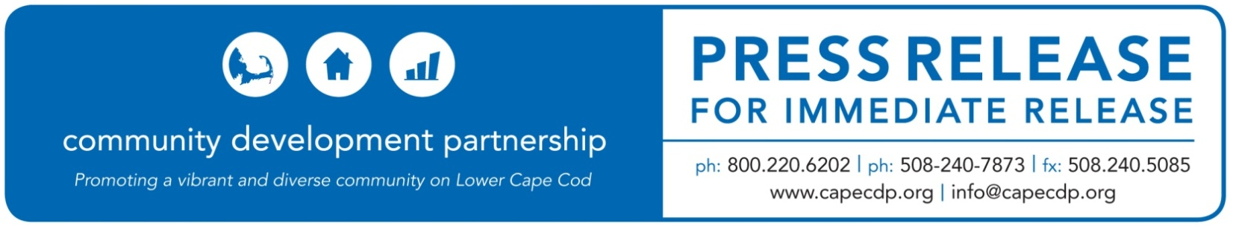
Eastham

What: Community Development Partnership Announces Staffing Changes
Release Date: September 17, 2020

For Additional Information Contact:
Britt Beedenbender, Chief Development and Communications Officer
Community Development Partnership
3 Main Street Mercantile, Unit 7, Eastham MA 02642
508-240-7873 ex 25, britt@capecdp.org

Community Development Partnership
Announces Staffing Changes and Welcomes Ronnie Edwards as CFO

The Community Development Partnership is pleased to announce the recent hire of Ronnie Edwards as
Chief Financial and Operations Officer. Edwards is a 24-year veteran of the US Foreign Service where he served in a number of key financial management positions for the US Agency for International Development. He brings to the CDP strong skills in financial reporting and financial system conversions as well as a deep understanding of the importance of community development.

Ronnie holds a Master’s in National Security Strategy from the National Defense University and a Bachelor’s in Business Administration from the University of Kentucky. He is fluent in Spanish and speaks basic Russian and Bahasa Indonesia. He was a Peace Corps Volunteer in Bolivia in the mid-1990s, and has since enjoyed volunteering in various capacities, including as President of a U.S. Embassy community association in Russia, and helping at-risk youth in El Salvador.

“I am thrilled to be joining the CDP as the new Chief Financial and Operations Officer during such a unique period in our country’s history,” says Edwards. “In my new role, I will manage the CDP’s system of internal controls, provide a full range of financial management services and guidance to the CDP’s staff, clients and partner organizations.”

Until last month, the CFOO position had been skillfully managed by Rob Doane who has moved over to lead the CDP’s property management efforts as the new Chief Property Management Officer.

“Rob has proven himself as a highly capable member of our team with his strong management and financial skills,” said Jay Coburn, CEO. “He has a great entrepreneurial spirit and will serve the CDP well as we expand our portfolio of managed properties. As a young professional living on the Outer Cape, Rob has first hand knowledge of the importance of the work we do to support small businesses and make housing affordable.”

ABOUT THE COMMUNITY DEVELOPMENT PARTNERSHIP

The Community Development Partnership leads the Lower Cape in building a diverse year-round community of people who can afford to live, work and thrive here. To accomplish our mission, we promote, develop and manage affordable housing; nurture the launch and growth of small businesses; and facilitate collaboration with business, non-profit and government partners.

To find out more information about this organization, go to www.capecdp.org.

###

